



USER

GUIDE

USER GUIDE

Pre-registration & Registration

N EW D E L H I

S EP T EM B ER 2 0 2 2

Table of Contents

1. Pre-registration 3

1.1 Export Pre-Registration 3

1.2 Import Pre-Registration 6

1.3 Add Pre-Registration 7

2. Registration 8

2.1 Export Registration 9

2.2 Import Registration 11

2.3 Add Registration 11

2.4 Approve/Reject Registration 14

2.5 Assign Mentor 17

## Pre-registration

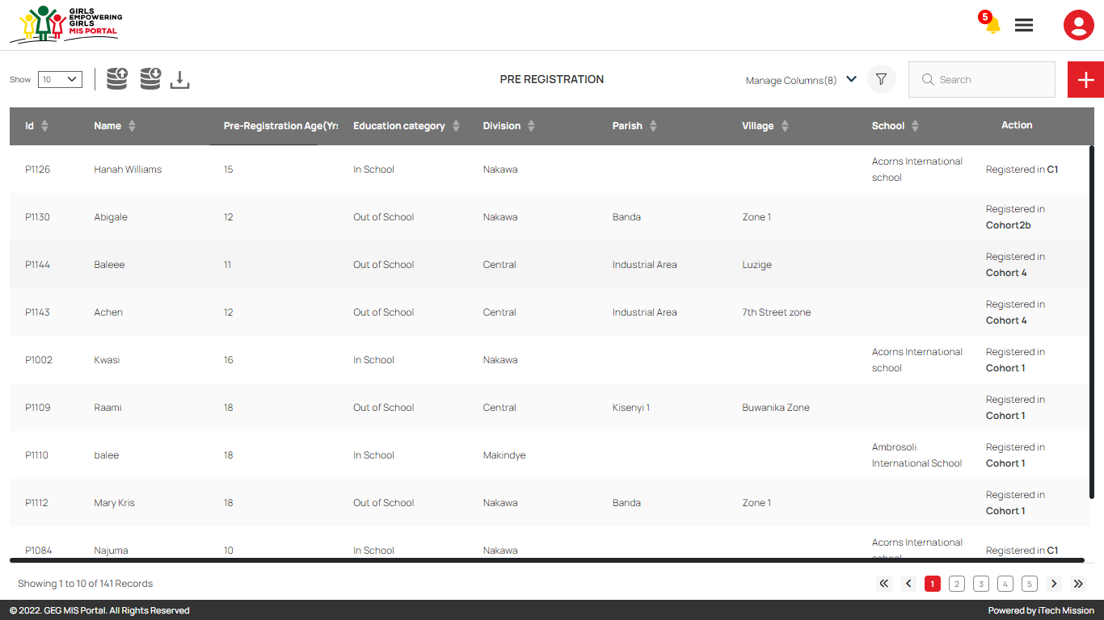Login as **Program Officer** to Pre-Register candidates. After successful login, click on the **Pre-Registration** option from burger menu to access this module. This module allows you to manage the pre-registered candidates of the GEG programme. You have the options to export and import a pre – registration template, add new candidate, view the list of existing candidates, sort the list, search candidate from the list, delete and update existing candidates (see figure below).

### 1.1 Export Pre-Registration

Click on the **Export** button to download the empty pre-registration template and pre-registered candidate list available in the database.

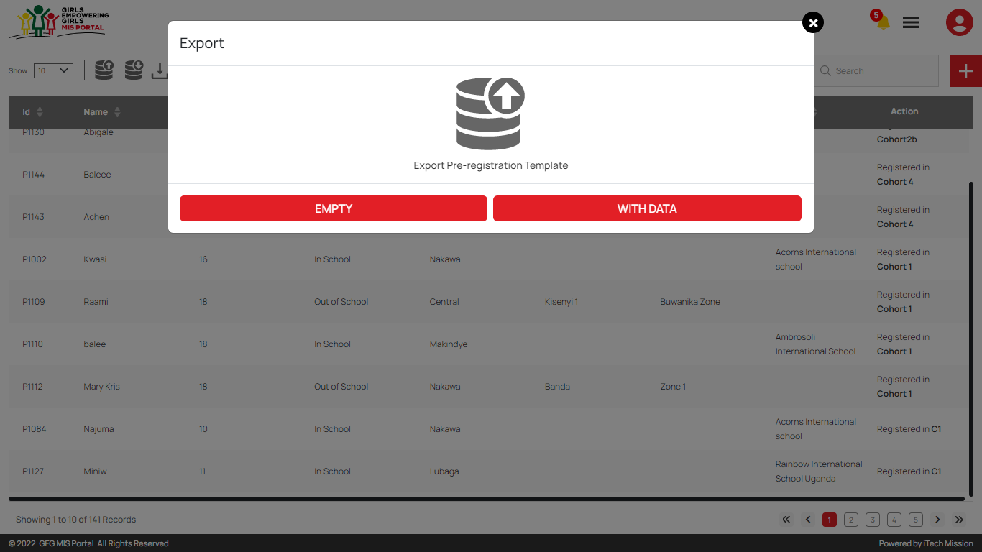Below is the structure of the pre-registration template.

|  |  |
| --- | --- |
| **Registration Date** | The pre-registration date of candidate |
| **Name** | Name of the pre-registered candidate |
| **Age** | Age of the pre-registration candidate |
| **Division** | Division in the candidate address |
| **Parish** | Parish in the candidate address |
| **School** | Name of the school (Incase candidate’s education category is In school). |
| **Village** | Village in the candidate address |
| **Education Category** | Education category of the candidate (Either In school or Out of School). |
| **School Status** | The status of candidate whether they are attending school or not. |
| **Year Dropped** | The Year candidate dropped out of school (When school status is selected as NO). |
| **Vulnerability Pregnant** | To determine incase the vulnerability of the pre-registered candidate is that she is pregnant. |
| **Vulnerability Disability** | To determine incase the vulnerability of the pre-registered candidate is disability. |
| **Vulnerability Refugee** | To determine incase the vulnerability of the pre-registered candidate is that she is refugee. |
| **Vulnerability Orphan** | To determine incase the vulnerability of the pre-registered candidate is that she is orphan. |
| **Vulnerability Other** | To determine incase the vulnerability of the pre-registered candidate is other than given options. |
| **Vulnerability Other Text** | Describe your vulnerability if you have selected other from given options. |
| **Caretaker Name** | Name of the person who takes care of the pre-registered candidate. |
| **Caretaker Contact** | Contact number of the person who takes care of the pre-registered candidate. |

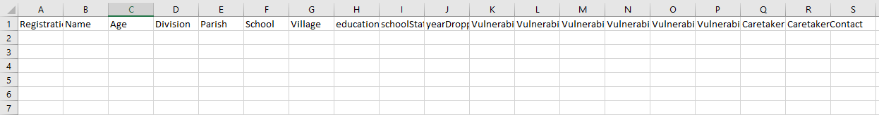Click on the **Empty** button to download an empty pre-registration template in CSV format (see below figure).

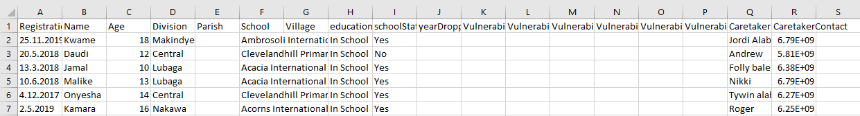Click on the **With Data** button to download the pre-registered candidate list available in the database (see below figure).

### 1.2 Import Pre-Registration

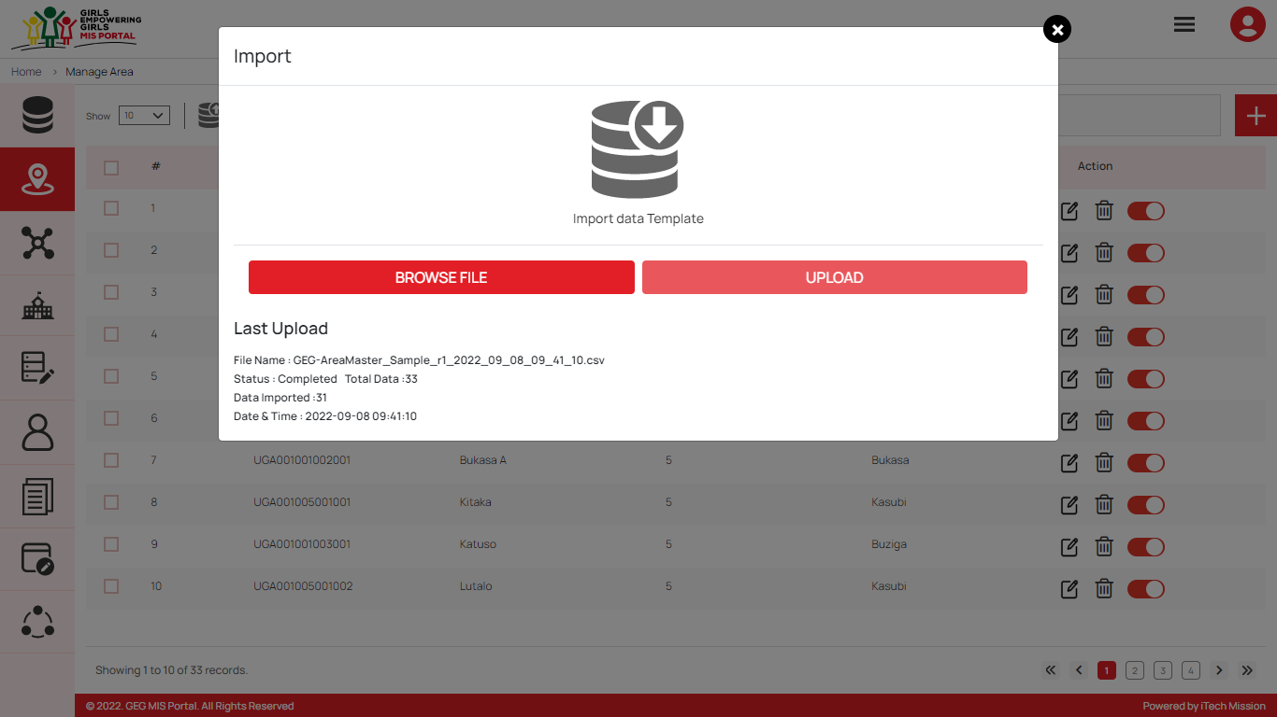Click on the **Import** button to browse the file and upload the candidate list into the database.

To upload the candidate list into the database, first enter the candidate details in the template as explained above and then click on the **Browse File** button to select the template. Now, click on the **Upload** button to start the import process. The records which will contains blank entries, entries with special characters and duplicate entries will not be imported in the database.

The **Last Upload** summary provides the count of total and imported records. A log will be generated for the failed records which were duplicate, failed, successfully inserted and updated into the database out of the total records.

### 1.3 Add Pre-Registration

****Click on the **Plus** button available to the right side of the page to **add** a new candidate in the pre-registered list (see figure below). Enter the following details to add a new candidate.

* Enter Candidate **Name**
* Enter **Pre-Registration Date**
* Enter **Pre-Registration Age**
* Select **Education Category** (either In school or Out of School)
* Select **Division**
* Select **Parish** (Incase education category is selected as Out of School)
* Select **Village** (Incase education category is selected as Out of School)
* Select **School** (Incase education category is as selected In School)
* Enter **Caretaker Name**
* Enter **Caretaker Address**

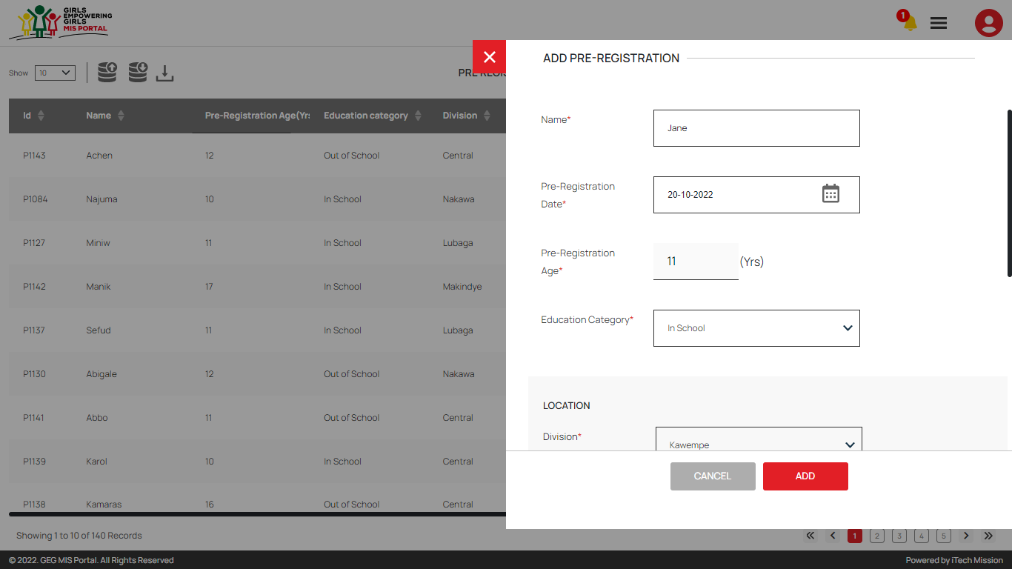All the details are mandatory to be entered. Click on the **Add** button to save and confirm. You can now view the candidate added in the pre-registration list.

Click on the **Edit** option from the Action column to edit any detail of the pre-registered candidate. Click on the Update button to save and confirm.

Click on the **Delete** option from the Action column to delete the selected candidate from the pre-registered list. When deleting a candidate, a confirmation popup will appear asking to confirm deletion. If clicked Yes, the selected record will be deleted.

Click on the **Disable** option from the Action column to disable the candidate. The disabled candidate will not be allowed for further registration process.

## Registration

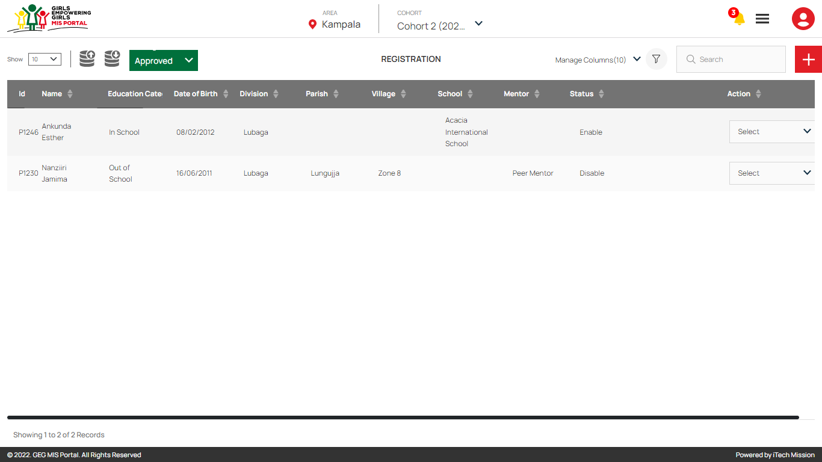Login as **Program Officer** and click on the **Registration** option from burger menu to access this module. This module is cohort and registration status driven. This module allows you to manage registration of participants in the GEG programme. You will have options to export and import a participant registration template, add new participant, view the list of existing participants, approve or reject a pending participant, sort, search, delete and update the participants (see figure below).

### 2.1 Export Registration

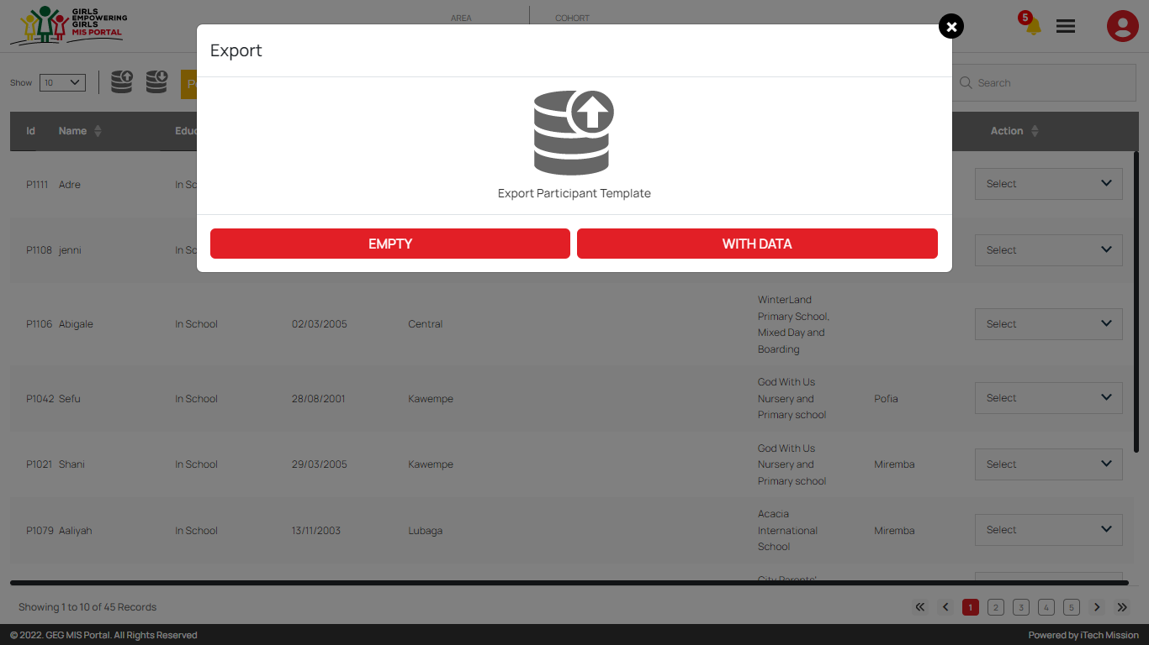****Click on the **Export** button to download the empty participant Registration template and participant list available in the database (See below figure).

Below is the structure of the registration template.

|  |  |
| --- | --- |
| **SNo** | The ID assigned to the pre-registered candidate |
| **Registration Date** | Date of registration of the participant |
| **Name** | Name of the of the participant |
| **DOB** | The date of birth of the participant |
| **Division** | Division of the participant |
| **Parish** | Parish of the participant |
| **School** | Name of the school of the participant. |
| **Village** | Village of the participant |
| **Education Category** | Education category of the participant |
| **School Status** | The status of participant whether they are attending school or not. |
| **Year Dropped** | The Year participant dropped out of school (When school status is selected as NO). |
| **Vulnerability Pregnant** | To determine incase the vulnerability of the pre-registered participant is that she is pregnant. |
| **Vulnerability Disability** | To determine incase the vulnerability of the pre-registered participant is disability. |
| **Vulnerability Refugee** | To determine incase the vulnerability of the pre-registered participant is that she is refugee. |
| **Vulnerability Orphan** | To determine incase the vulnerability of the pre-registered participant is that she is orphan. |
| **Vulnerability Other** | To determine incase the vulnerability of the pre-registered participant is other than given options. |
| **Vulnerability Other Text** | Describe your vulnerability if you have selected other from given options. |
| **Caretaker Name** | Name of the person who takes care of the pre-registered participant. |
| **Caretaker Contact** | Contact number of the person who takes care of the pre-registered participant. |

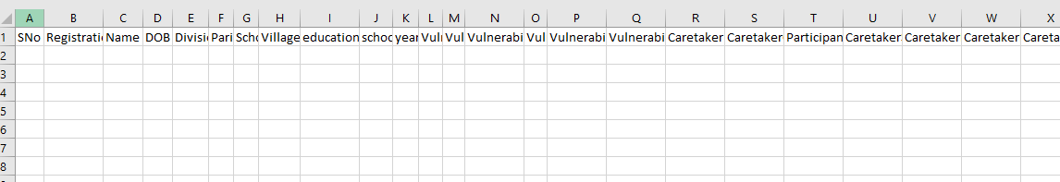Click on the **Empty** button to download an empty registration template in CSV format (see below figure).

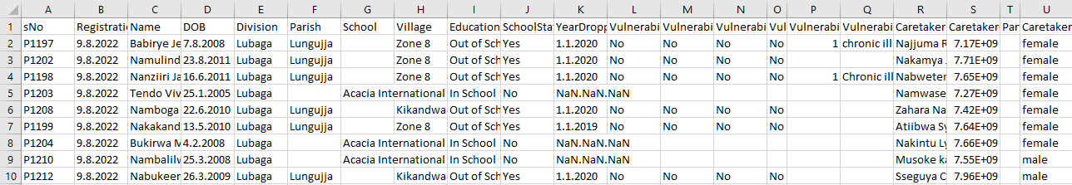Click on the **With Data** button to download the registration list available in the database (see below figure).

### 2.2 Import Registration

Click on the **Import** button to browse the file and upload the participant list into the database.

To upload the participant list into the database, first enter the participant details in the template as explained above and then click on the **Browse File** button to select the template. Now, click on the **Upload** button to start the import process. The records which contain blank entries, entries with special characters and duplicate entries will not be imported in the database.

The **Last Upload** summary provides the count of total and imported records. A log will be generated for the failed records which were duplicate, failed, successfully inserted and updated into the database out of the total records.

### 2.3 Add Registration

****Click on the **Plus** button available to the right side of the page to **add** a new participant.

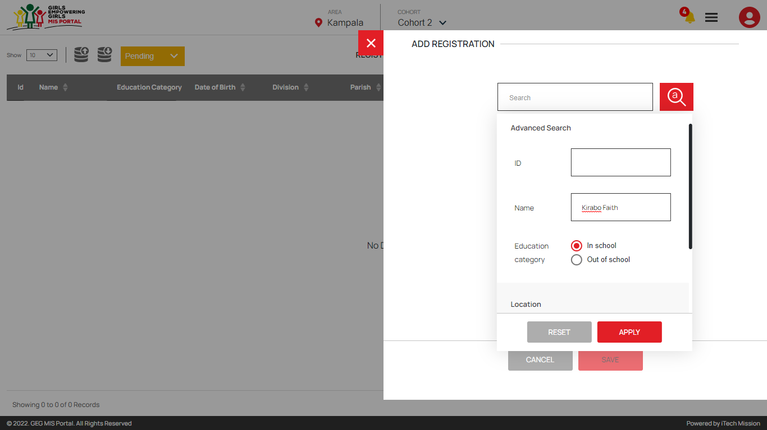Enter the pre-registered candidate name or id in the search bar to select the candidate for further registration. You can also use **Advance Search** to select the candidate from the available list. Click on the Advance Search option available with the search bar and select the option to filter the candidate list by Name, ID, Education Status and Location (See below figure).

After selecting the candidates, enter the following details to add selected candidate as participant.

* Enter Participant **Name**
* Upload **Participant Photograph** (Optional)
* Select Participant **DOB**
* Select **Education Category** (either In school or Out of School)
* Enter **NIN** **Number**
* Select **Nationality**
* Select **Registration Date**
* Select **Division**
* Select **Parish** (Incase education category is selected Out of School)
* Select **Village** (Incase education category is selected Out of School)
* Select **School** (Incase education category is selected In School)
* Enter **Care taker details**
* Enter **Care taker location**

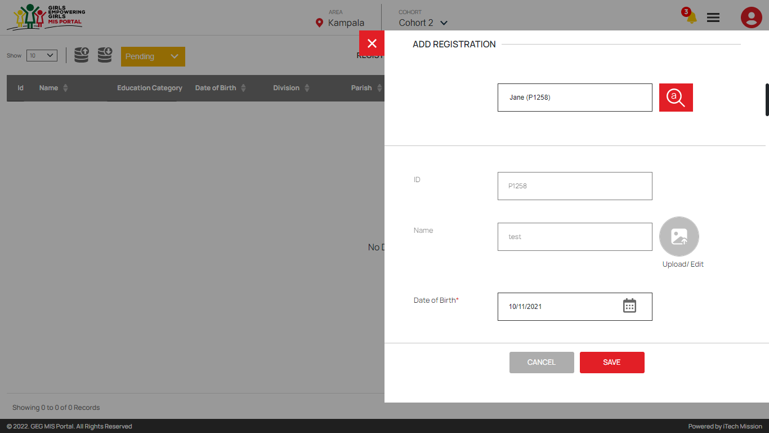All the required details are mandatory to be entered (see below figure).

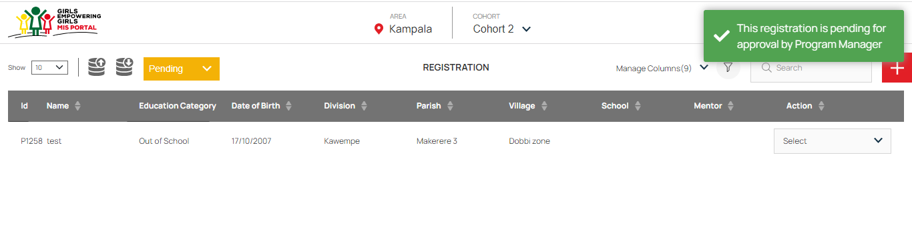Click on the **Add** button to save and confirm. You can now view the participant added in the registration list (see below figure).

The registered participant will remain in **pending** state until approved by the program manager.

Click on the **Edit** option from the Action column to edit any detail of the registered participant. Click on the Update button to save and confirm.

Click on the **Delete** option from the Action column to delete the selected participant from the registered list. When deleting a candidate, a confirmation popup will appear asking to confirm deletion. If clicked Yes, the selected record will be deleted.

Click on the **Disable** option from the Action column to disable the participant. The disabled participant will not be allowed for further cash transfer process.

### 2.4 Approve/Reject Registration

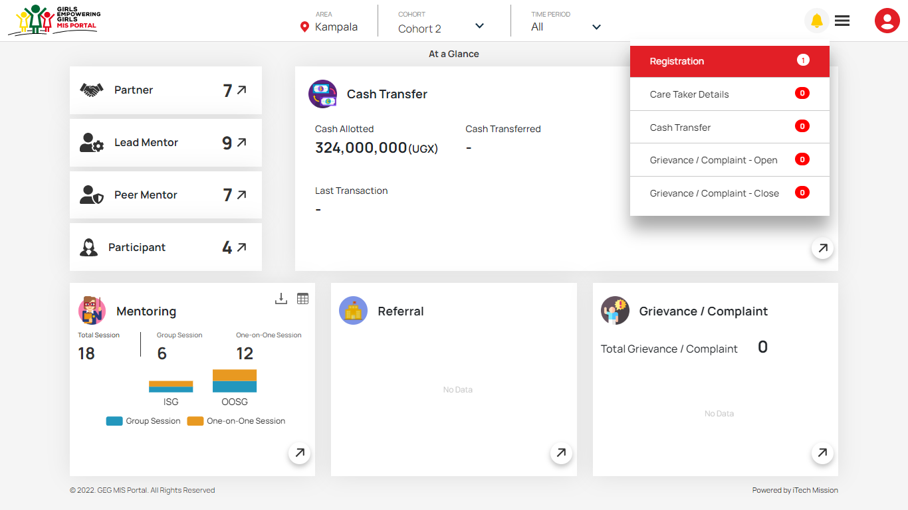Login as **Program Manager** to approve and reject registration of participants. You will receive notification when any participant is registered and needs approval. Click on the notification button to view the received notification (see below figure).

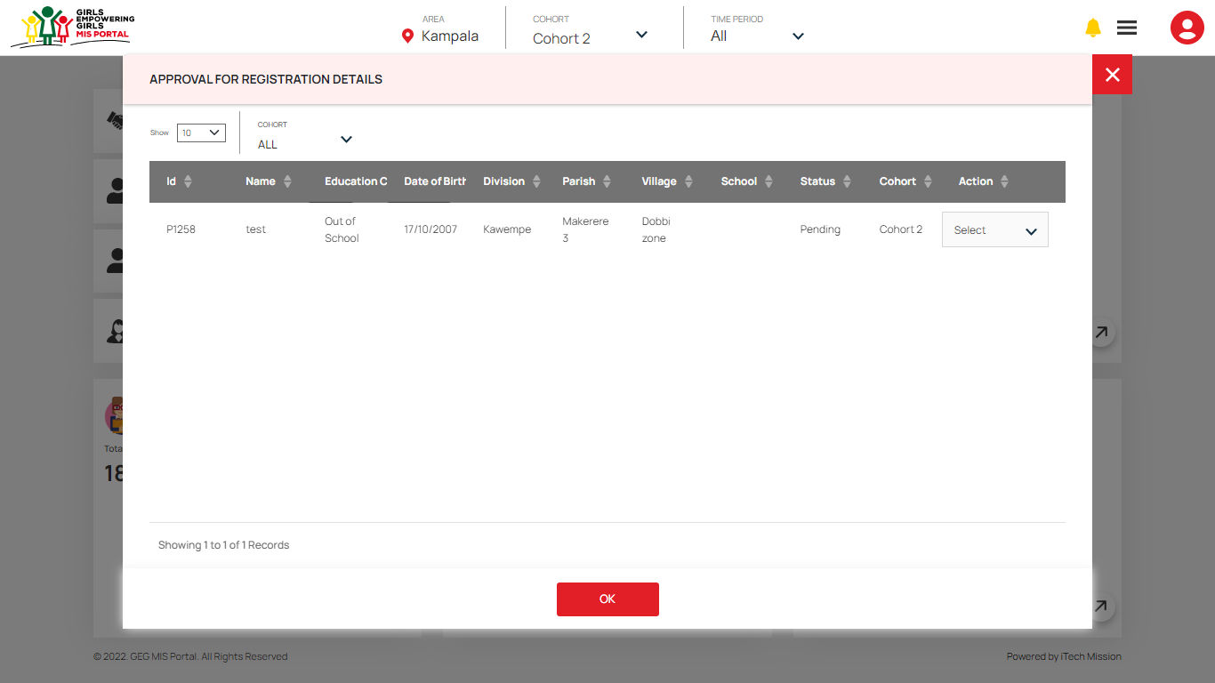Click on the **Registration** category from the notification menu to view the newly registered participants that needs approval.

Select cohort in the notification window to view all the pending participant of the selected cohort. You can approve or reject the participant from the notification window as well as using the registration module.

The Program Manager will have the option to Move a Pending Registration to one of the following states –

* Approved
* Rejected

#### Approve Participants

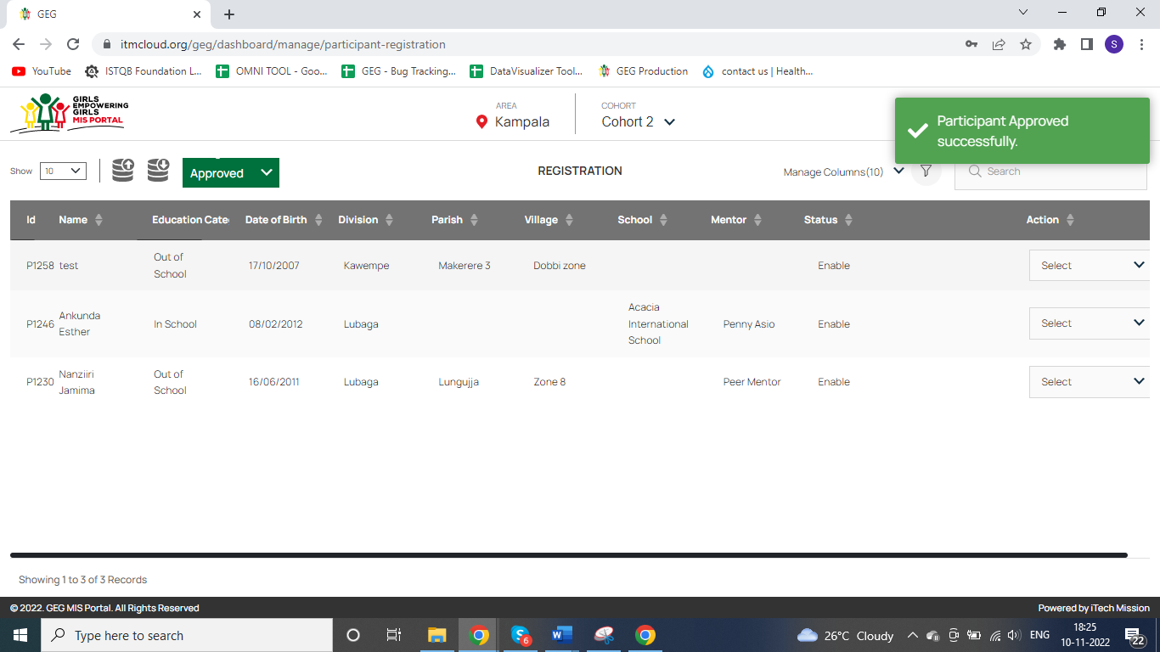In the list of Pending Registrations, click on the **Approve** option from action column to approve the selected participant. The approved participant will be moved to approved registration list and notification will be sent to the program officer for the same (see below figure).

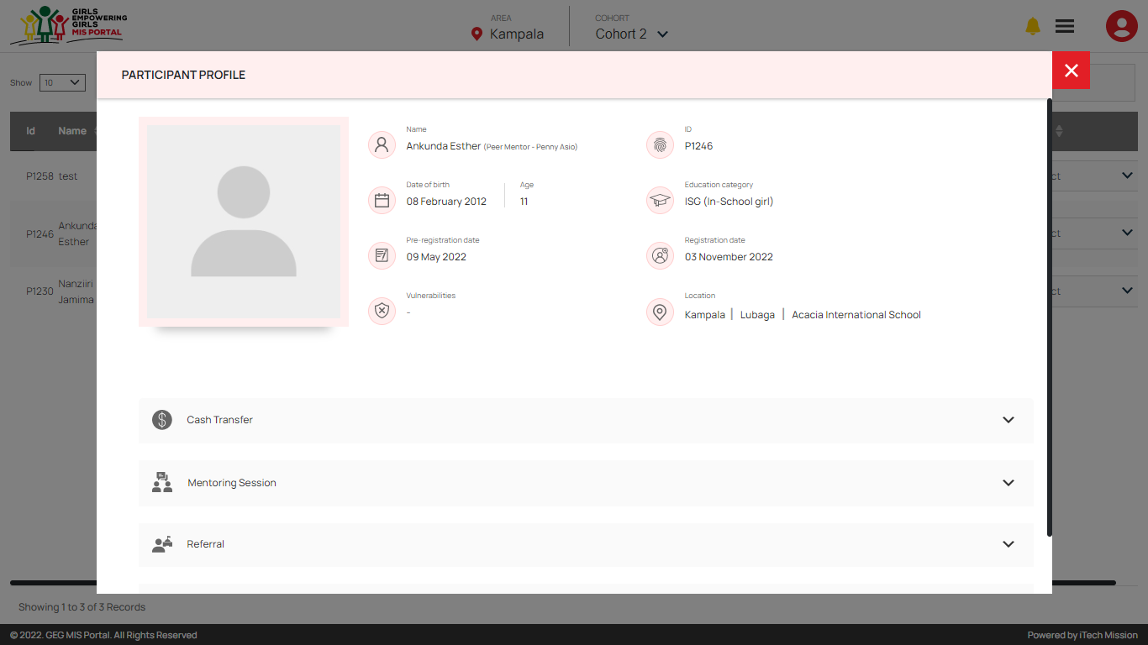You can View the detailed profile of the approved participant by selecting **View** option from the Action column (See below figure).

#### Reject Participants

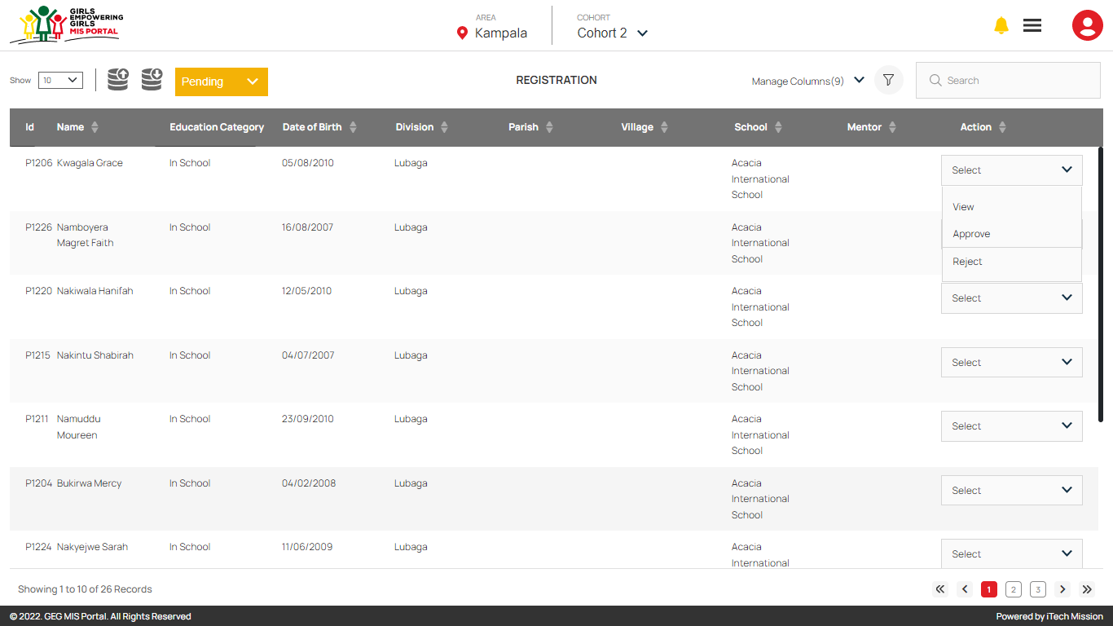In the list of Pending Registrations, click on the **Reject** option from action column to reject the selected participant (see below figure).

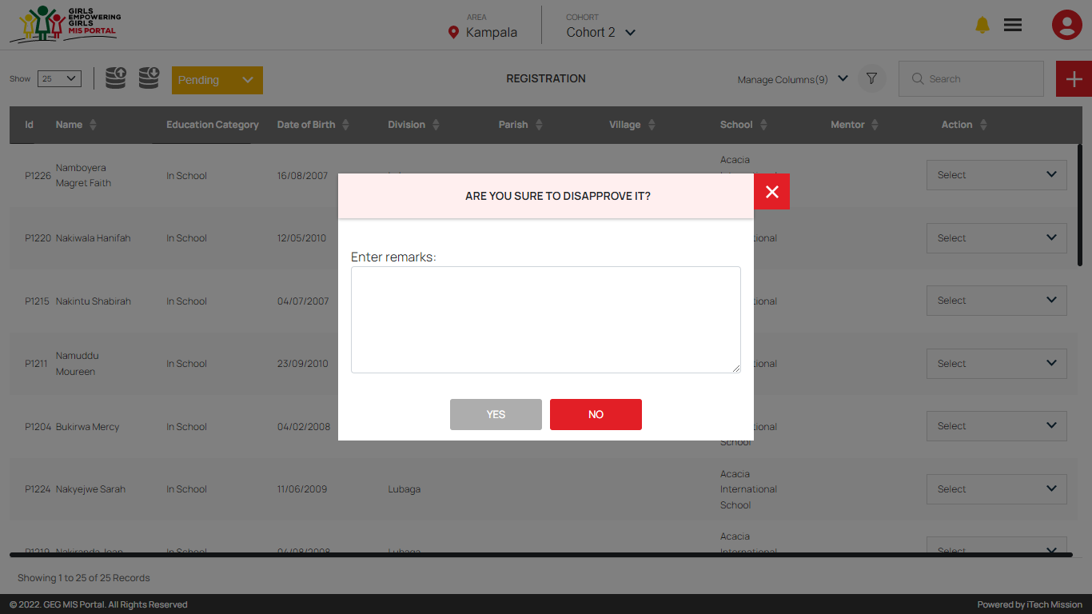You can also enter the reason of rejection when rejecting the participant (See below figure).

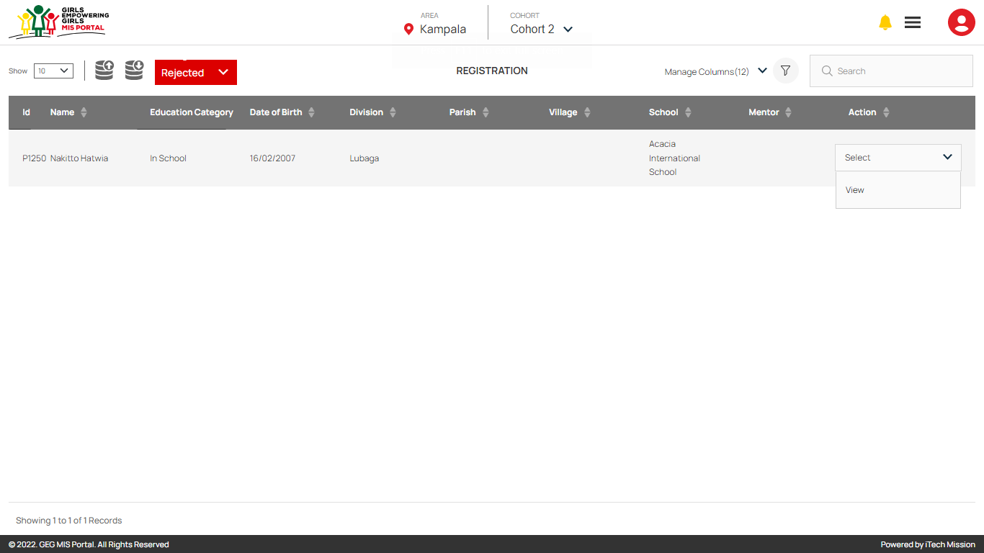The rejected participants will be moved to list of rejected participant and notification will be sent to the program officer for the same (see below figure).

You can view the detailed profile of the rejected participant by selecting **View** option from the Action column.

### 2.5 Assign Mentor

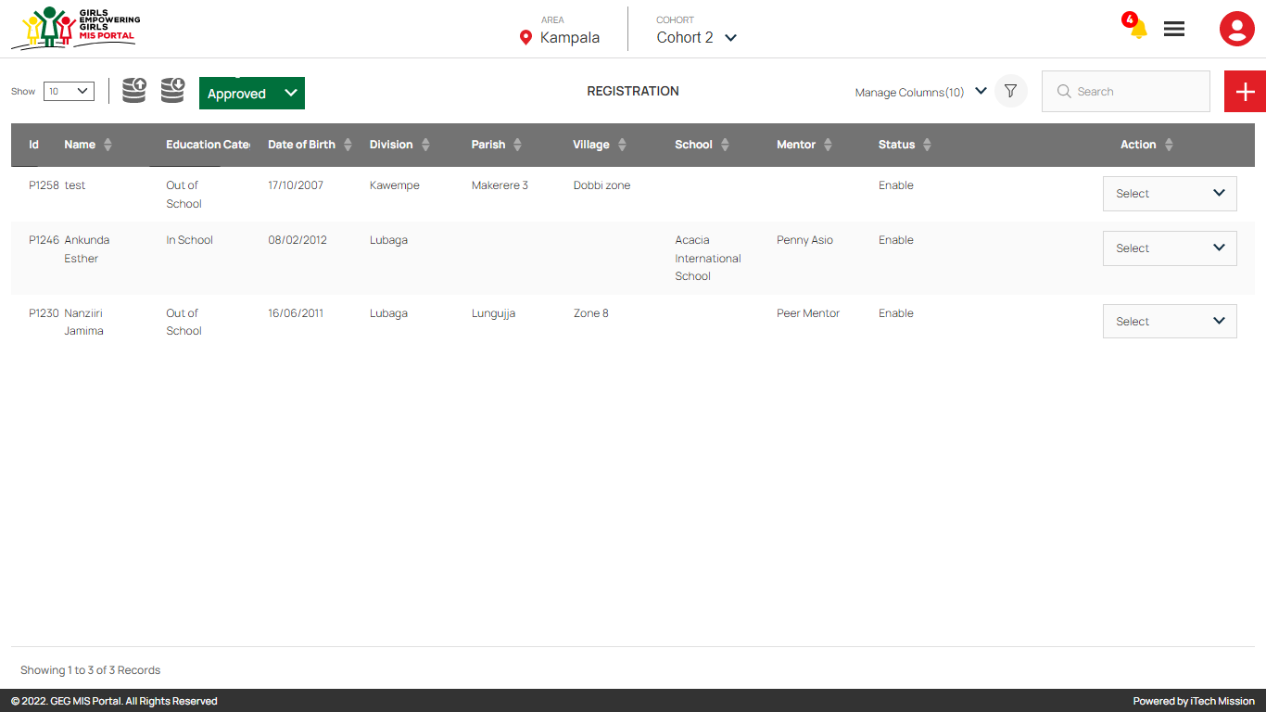Login as **Program Officer** to assign mentor to the approved participants. Navigate to the Registration module to view the list of participants. Click on the dropdown available to the right side of the import button and select the option Approved to view the list of approved participants (see below figure).

Click on the Select dropdown to perform the following actions on the approved participants –

* View
* Enable/Disable
* Edit Caretaker
* Delete
* Assign Mentor

Select **Assign Mentor** option to assign the mentor to the selected participant.

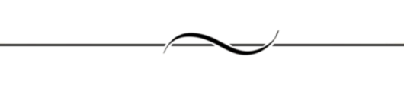END OF THE DOCUMENT